Python - Integrated Development Environment

Python - IDLE
IDLE (Integrated Development and Learning Environment) is an integrated development environment (IDE) for Python. The Python installer for Windows contains the IDLE module by default.
To start IDLE interactive shell, search for the IDLE icon in the start menu and double click on it.
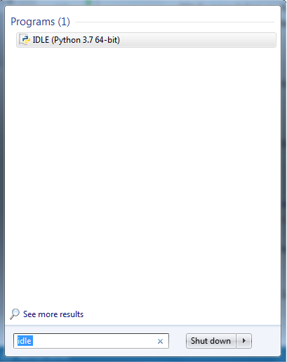Python IDLE
This will open IDLE, where you can write Python code and execute it as shown below.
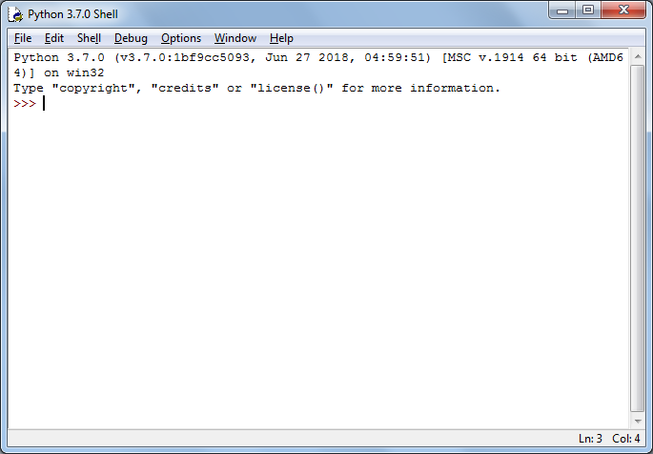Python IDLE
Now, you can execute Python statements same as in Python Shell as shown below.
Python IDLE
To execute a Python script, create a new file by selecting File -> New File from the menu.
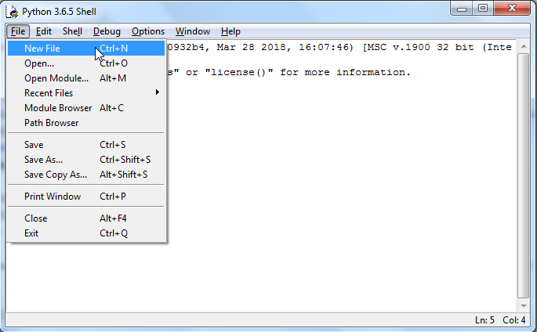
Enter multiple statements and save the file with extension .py using File -> Save. For example, save the following code as hello.py.
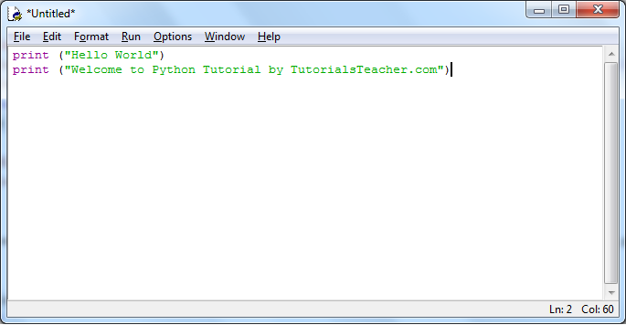Python Script in IDLE
Now, press F5 to run the script in the editor window. The IDLE shell will show the output.
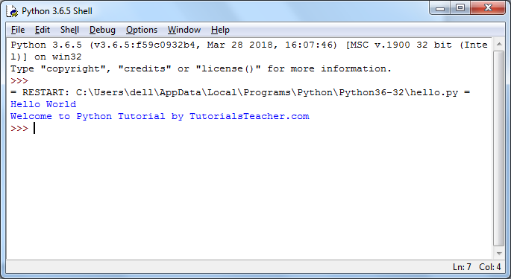Python Script Execution Result in IDLE
Thus, it is easy to write, test and run Python scripts in IDLE.

